***SONET PROJECT***

* VEHICLE INFORMATION

**TEAM MEMBERS**

* Prerna Patra 17BD1A051D
* Siripuram Sanjana 17BD1A051L
* Abhishek Ummadi 17BD1A051T
* Nikitha Vujjini 17BD1A051U

**ABSTRACT**

This skill gives the information of a vehicle when the **number of the vehicle** is entered

Gives information like:

* Owner’s Name
* Owner’s Father Name
* Owner’s Address
* Maker’s class
* Vehicle class
* Fuel Used
* Chassis Number
* Engine Number
* Unladen Weight
* Color
* Date of Registration
* Month year of Manufacture
* Challan updates

**Example Output:**

Open Vehicle Information skill

**Welcome to Alexa Vehicle skill. Please enter your vehicle number**

TS08FX5692

**The basic details of the vehicle are**

**Owner’s Name : Prerna Patra**

**Owner’s Father Name : S K Patra**

**Owner’s Address : SR: 456/78 HN: 34-77/20/39 Malkajgiri, Secunderabad**

**DO YOU WANT FURTHER INFORMATION?**

Yes

**Please enter the required choice**

1. **Maker’s class**
2. **Vehicle class**
3. **Fuel Used**
4. **Chassis Number**
5. **Engine Number**
6. **Unladen Weight**
7. **Color**
8. **Date of Registration**
9. **Challan updates**

9

**Challan updates : No helmet in the area Jubliee Hills**

**Charges- Rs 500/-**

**DO YOU WANT FURTHER INFORMATION?**

Yes

**Please enter the required choice**

1. **Maker’s class**
2. **Vehicle class**
3. **Fuel Used**
4. **Chassis Number**
5. **Engine Number**
6. **Unladen Weight**
7. **Color**
8. **Date of Registration**
9. **Month year of Manufacture**
10. **Challan updates**

3

**Fuel Used: Petrol**

**DO YOU WANT FURTHER INFORMATION?**

No

**Thankyou for visiting our skill**

Stop

**Goodbye**

**INTRODUCTION TO PROJECT**

The Vehicle Information skill gives all the necessary information about a vehicle.

This is useful as we can be updated about our vehicle’s details.

**HARDWARE AND SOFTWARE REQUIREMENTS**

Software requirements

1. Amazon developer account for developing interaction model
2. Eclipse IDE for developing the skill
3. AWS Lambda service for hosting the skill.

**PROJECT ARCHITECTURE**

**Step** 1: Design Your Voice Experience. ...

**Step** 2: Build Your Voice User Interface in the **Alexa** Developer Console. ...

**Step** 3: Build Your Back End to Power Your **Skill**. ...

**Step** 4: Test and Optimize. ...

**Step** 5: Submit, Get Certified, and Publish.

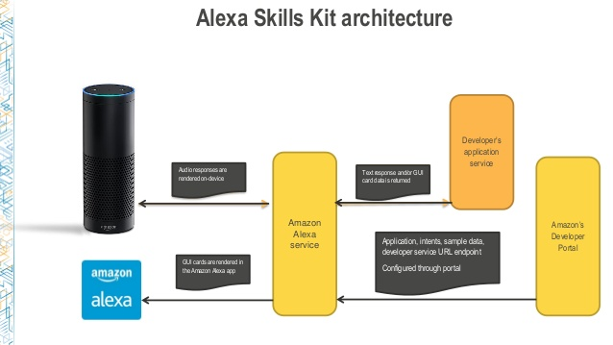

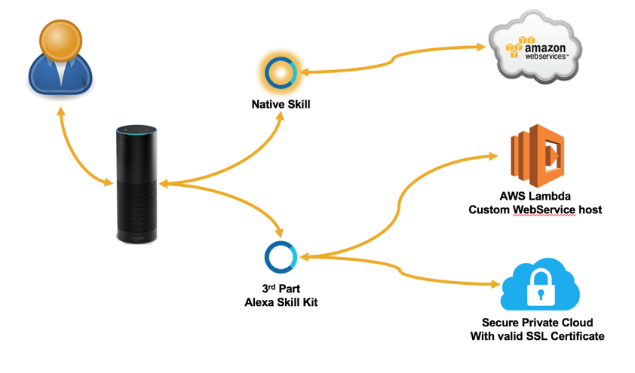

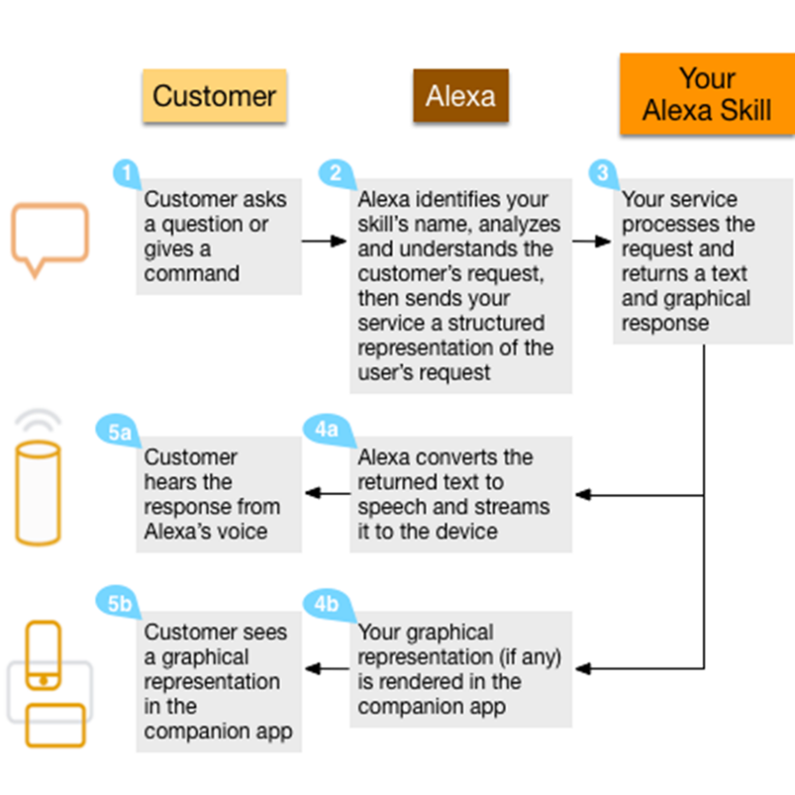

**MODULES INVOLVED**

**Lambda Service**

AWS Lambda service is used to host this skill

ARN ID- arn:aws:lambda:us-east-1:007413471047:function:PrernaPatra

**Developer Portal**

Name of the skill – guessing game

Skill id - amzn1.ask.skill.223fab9b-e46d-4dd1-a66d-c966c7e6f702

**Skill Interface**

The skill interaction model consists of the following

* **Invocation Name**

Sample utterance: vehicle information skill

* **FirstIntent**

Sample utterance: My number is {vehicvleno}

* **YesornoIntent**

Sample utterance: My answer is {answer}

* **OptionIntent**

Sample utterance: {choice}

* **Custom slots**

1. answers – Yes , No

**IMPLEMENTATION STEPS**

**Step 1**- Invoke the skill using invocation name: vehicle information skill

**Step 2**- Give the vehicle number when asked

**Step 3-** After the basic information is displayed. For further information enter yes. And enter no if you don’t want further information.

**Step 4**- When the list is displayed. Select the option.

**Step 5**- Say *stop* to stop the skill.

**TESTING**

Below are few snap shots which describe about the testing steps of the skill

A screenshot of a computer screen

Description generated with very high confidence

A screenshot of a computer screen

Description generated with very high confidence

A screenshot of a computer screen

Description generated with very high confidence

A screenshot of a computer screen

Description generated with very high confidence

**Future Scope**

This can be useful in the case of occurrence of an accident to get the important details about the owner by entering the vehicle number in the skill.

**Reference**

<https://www.hackster.io/amazon-alexa/projects?sort=trending&page=4>